Cloud Computing - Overview

Computing: Any goal oriented activity requiring, benefiting from or creating computers.

**Trends in Cloud Computing:**

Distributed Computing

Grid Computing

Clustered Computing

Utility Computing

Cloud Computing

Distributed Computing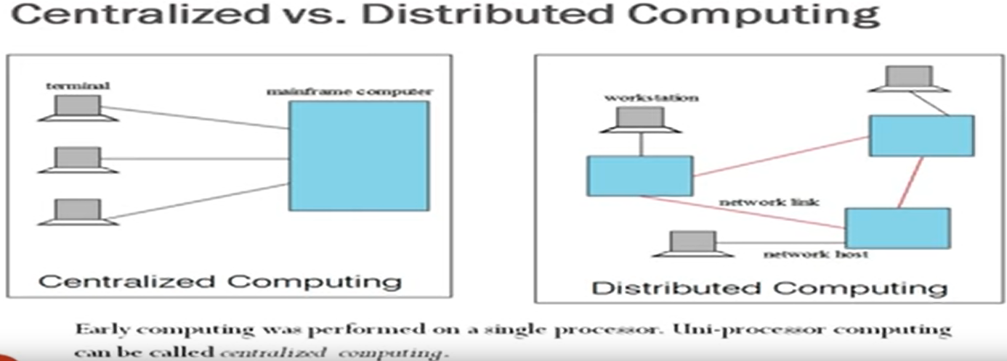

Availability of seamless network connectivity is important for distributed computing.

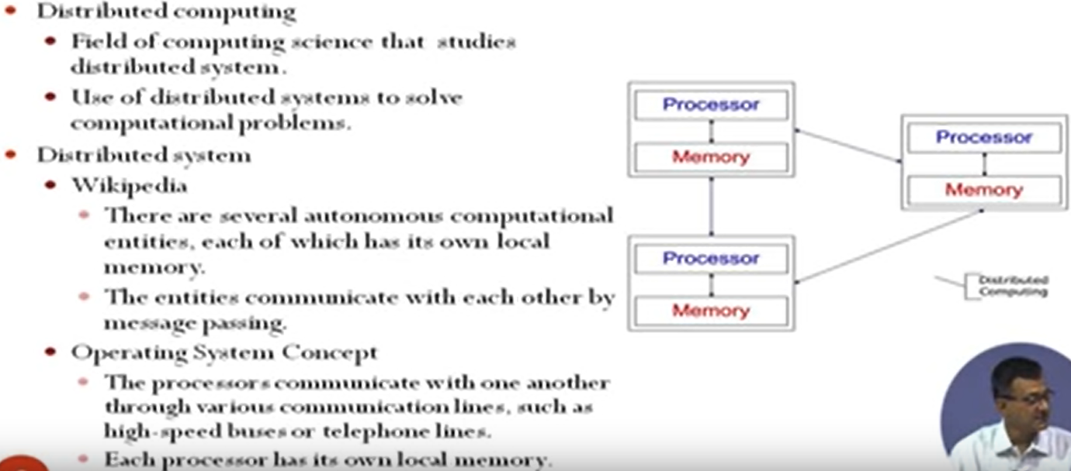

**Examples of Distributed Systems :**

Internet, ATM Machines, Intranets etc

**Computers (Nodes) in a Distributed System:**

1. Workstations
2. Personal Assistance Devices: Handheld computers connected to the system via a wireless communication link.
3. Server Systems

**Common Properties of Distributed Computing**

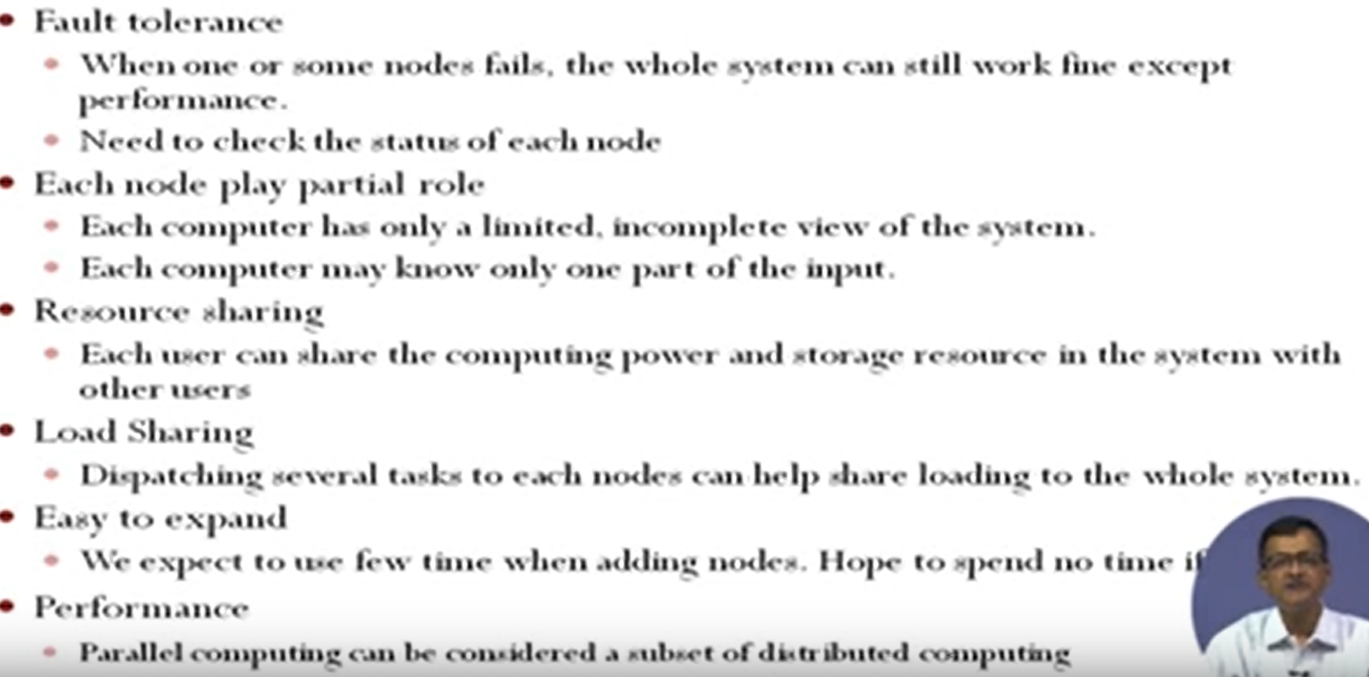

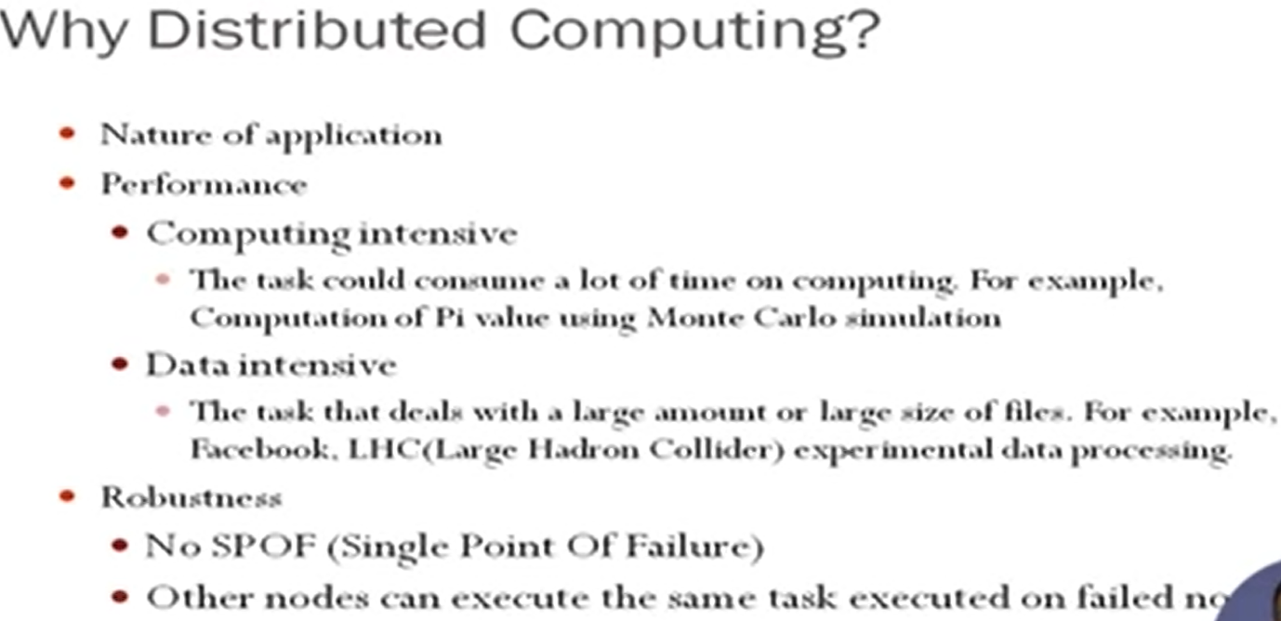

**GRID COMPUTING:**

It is a collection of computer resources from multiple locations to reach a common goal.

Grid Computing Vs Distributed System : Non interactive workload (i.e the systems don’t interact with one another) that involve processing a large task.

It is a computing infrastructure that provides dependable consistent, pervasive and inexpensive access to computational capabilities.

Grid Computing Requires :

1. A Grid Server which handle administrative duties for managing the systems.
2. A collection of computer s/w called middle ware
3. User systems.

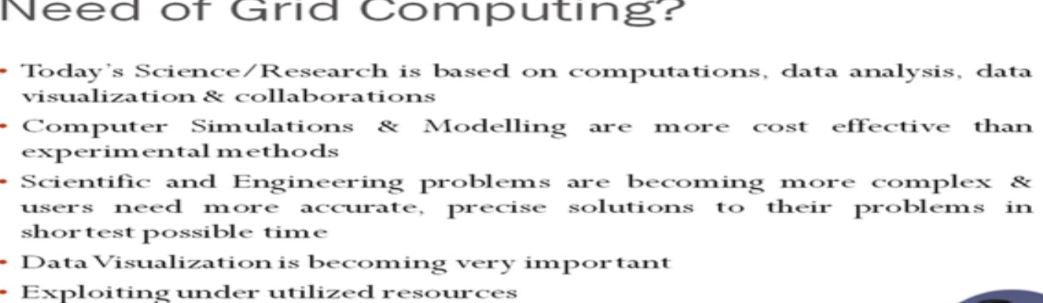

**CLUSTER COMPUTING**

A cluster is a type of parallel/distributed computer system, which consists of a collaboration of inter-connected stand-alone computers working together as a singe integrated computing resource.

Why Cluster Computing?

Clusters are usually deployed to improve speed and reliability over that provided by a single computer, while typically being much more cost effective than single computer the of comparable speed or reliability.

Types of Clusters :

1. High Availability or Failure Cluster
2. Load Balancing Cluster
3. Parallel / Distributed Cluster

Key Operational Benefits of Clustering :

System Availability, H/w fault tolerance, OS and application reliability, Scalability, High Performance

**Utility Computing**

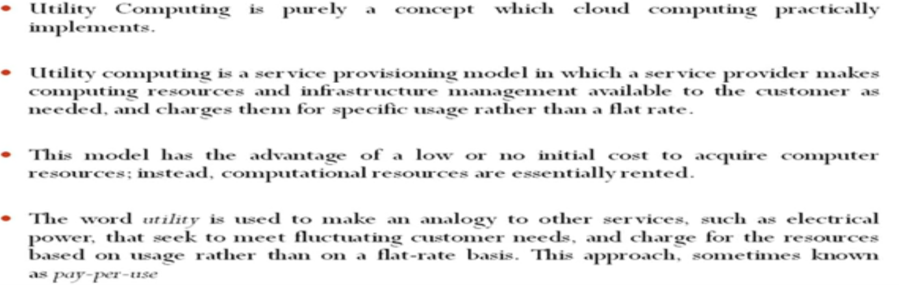

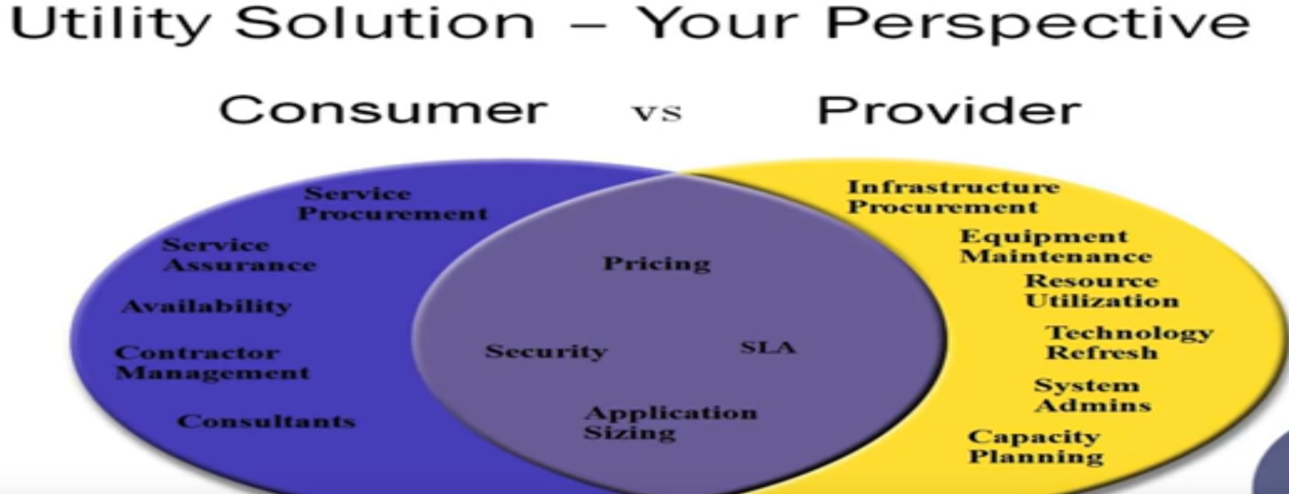

**Risk in Utility Computing:**

1. Data Backup
2. Data Security
3. Partner Competency
4. Defining SLA (Service Level Agreements)
5. Getting value for charge back

<https://data-flair.training/blogs/grid-computing-vs-cloud-computing/>

<https://searchdatacenter.techtarget.com/definition/utility-computing>

# Cloud Computing - Introduction

Cloud computing is a model enabling ubiquitous, on demand n/w access to a shared pool of resources (e.g n/w servers storage apps and services) that can be rapidly provisioned and released with minimal mgmt effort or service provider interaction.

**Characteristics**

1. On Demand self Service
2. Resource Pooling
3. Broad N/W access
4. Measured and Pay for use model
5. Rapid elasticity
6. Resilient Computing
7. Geographic Distribution
8. Virtualization
9. Advanced Security
10. Service Oriented Architecture (SOA)

**Cloud Service Models :**

SaaS

Word Processing, Spread Sheet etc applications are present on internet. All these applications are somewhere present in the cloud. As a user I am able to use those applications via my web browser. This is called Software as a service. I am unaware of background and maintenance of the app.

Ex: Email, CRM, Virtual Desktop, games etc

IaaS

I am visualizing the whole system on my desk. i.e

Ex: VM’s, Servers, storage, load balencers, networks etc

PaaS

An execution platform which allows to run the application, test the application etc.

Ex: Web Servers, development tools, databases etc

**Cloud Clients**

Web Browser, Mobile app, terminal, thin client, emulator etc

**Types of Cloud:**

1. Private Cloud
2. Community Cloud
3. Public Cloud
4. Hybrid Cloud

**Cloud Storage**

Storage of huge data.

Ex: Amazon EC2 and S3

**Advantage of Cloud Computing:**

**Disadvantage of Cloud Computing:**